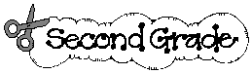
Welcome to…

We’re looking forward to having a great year with you. We will have lots of fun learning together. To help us get started students are asked to bring in the following supplies:

- Headphones (each child requires their own)
- Four packs of 3 x 3 super sticky Post-it note pads (no accordion)
- Two JUMBO glue sticks (to be replaced when needed)
- Four 2-pocket durable plastic folders with horizontal pockets
- One plastic school supply box to hold crayons and glue sticks
- Smock or old shirt for art class (labeled with your child’s name)
- One composition book, wide ruled
- One box of 24 count crayons
- One pack of colored pencils 24 count
- Three Paper Mate Flair pens in black
- One box of SANDWICH size Ziploc bags
- One bod of GALLON size Ziploc bags
- Four packages of Ticonderoga sharpened No. 2 pencils
- One yellow highlighter
- One soft-sided pencil pouch with zipper
- One pair of child sized scissors
- Five Expo markers
- Coins in a baggie for Math: 25 pennies, 10 nickels, 10 dimes, and 5 quarters

Please have these items ready for the first day of school.

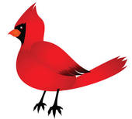
We hope you have a wonderful summer, and we look forward to seeing you on Thursday, September 5th.
Love,

The Second-Grade Teachers

